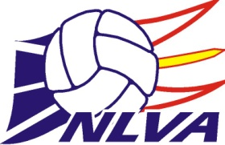2026 Annual Awards Application Form

Applicant Name: ________________________________________________
Award Selection: (Please Circle Below)
JUNIOR HIGH PLAYER OF THE YEAR AWARD - Male
JUNIOR HIGH PLAYER OF THE YEAR AWARD - Female
ROBBIE WEST MEMORIAL AWARD (Senior High Player of the Year - 16U-18U) – Male
ROBBIE WEST MEMORIAL AWARD (Senior High Player of the Year - 16U-18U) - Female
JUNIOR HIGH TEAM OF THE YEAR
SENIOR HIGH TEAM OF THE YEAR
JUNIOR CLUB TEAM OF THE YEAR (14U-15U)
(Information can be sent in immediately following Nationals for this these age groups)
SENIOR CLUB TEAM OF THE YEAR (16U-18U)
(Information can be sent in immediately following Nationals for this these age groups)
JUNIOR HIGH COACH OF THE YEAR AWARD
SENIOR HIGH COACH OF THE YEAR AWARD

2025-2026 Accomplishments/Teams:

2025-2026 Awards:

2025-2026 Other Volleyball Activities

