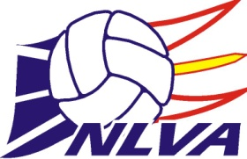2025 Annual Awards Application Form

**Applicant Name: ________________________________________________**

**Award Selection: (Please Circle Below)**

JUNIOR HIGH PLAYER OF THE YEAR AWARD - Male

JUNIOR HIGH PLAYER OF THE YEAR AWARD - Female

ROBBIE WEST MEMORIAL AWARD (Senior High Player of the Year - 16U-18U) – Male

ROBBIE WEST MEMORIAL AWARD (Senior High Player of the Year - 16U-18U) - Female

JUNIOR HIGH TEAM OF THE YEAR

SENIOR HIGH TEAM OF THE YEAR

JUNIOR CLUB TEAM OF THE YEAR (14U-15U)

(Information can be sent in immediately following Nationals for this these age groups)

SENIOR CLUB TEAM OF THE YEAR (16U-18U)

(Information can be sent in immediately following Nationals for this these age groups)

JUNIOR HIGH COACH OF THE YEAR AWARD

SENIOR HIGH COACH OF THE YEAR AWARD

**2024-2025 Accomplishments/Teams:**

**2024-2025 Awards:**

**2024-2025 Other Volleyball Activities**