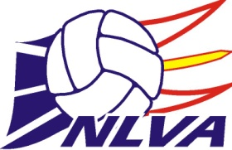2024 Annual Awards Application Form

Applicant Name: ________________________________________________
Award Selection: (Please Circle Below)
JUNIOR HIGH PLAYER OF THE YEAR AWARD - Male
JUNIOR HIGH PLAYER OF THE YEAR AWARD - Female
ROBBIE WEST MEMORIAL AWARD (Senior High Player of the Year - 16U-18U) – Male
ROBBIE WEST MEMORIAL AWARD (Senior High Player of the Year - 16U-18U) - Female
WAYNE SHEPPARD MEMORIAL AWARD (Senior Player of the Year - 19U & above) – Male
WAYNE SHEPPARD MEMORIAL AWARD (Senior Player of the Year - 19U & above) - Female
JUNIOR HIGH TEAM OF THE YEAR
SENIOR HIGH TEAM OF THE YEAR
JUNIOR HIGH COACH OF THE YEAR AWARD
SENIOR HIGH COACH OF THE YEAR AWARD

2023-2024 Accomplishments/Teams:

2023-2024 Awards:

2023-2024 Other Volleyball Activities:

